Q1. Room Volume Calculation Design a class named Room with three data members: height, width, and breadth.

Include a method volume() to compute and return the volume of the room.

Create a separate class RoomDemo that creates instances of the Room class and displays the volume for each instance.

Ans :

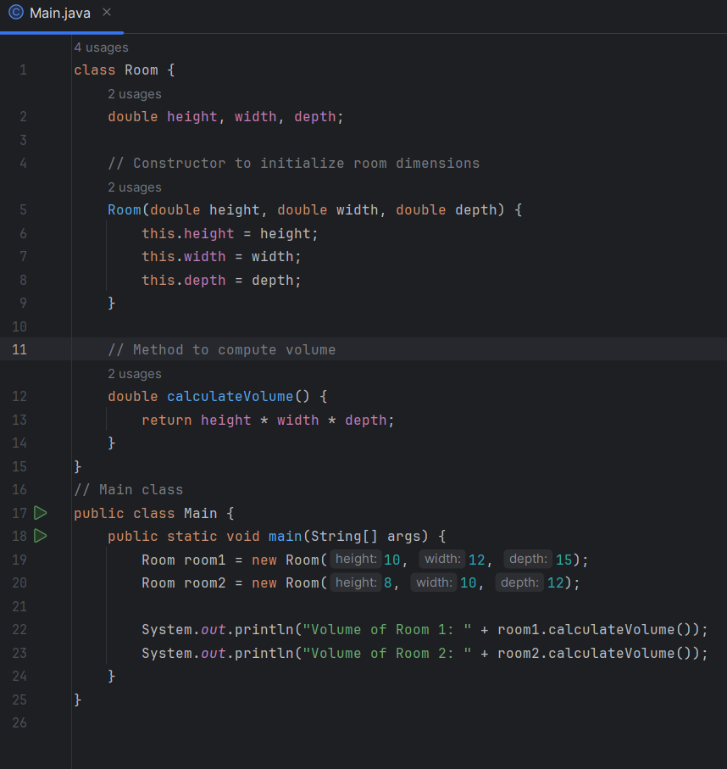

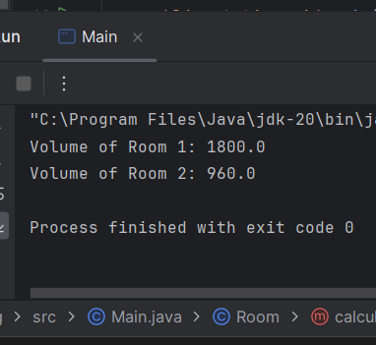

Q2. Student Marks and Average Create a class Student with the following members:

● Name of the student

● Marks in three subjects

● A method to assign initial values

● A method to compute the total and average marks

● A method to display the student’s name and total marks

Write a main() method to demonstrate the functionality of the class.

Ans

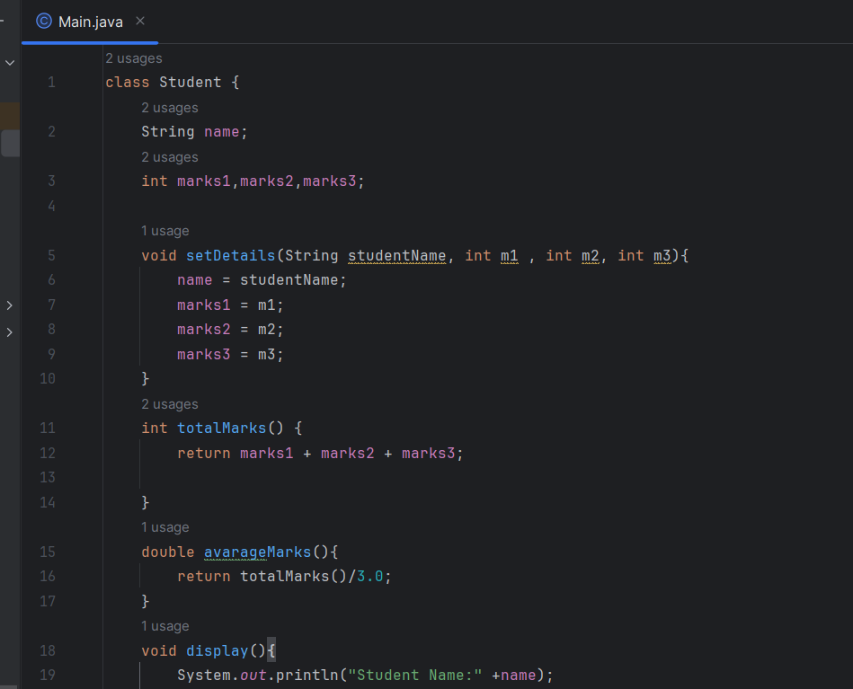

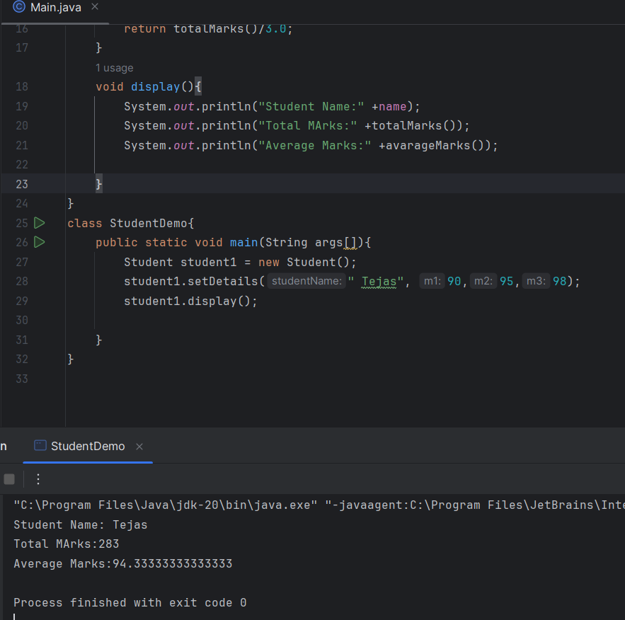

3. Box Area and Volume Write a class Box with three member variables: height, width, and breadth. Include appropriate constructors to initialize these variables. Also, implement two m.ethods:

● getVolume() to return the volume of the box

● getArea() to return the surface area of the box Create two instances of the Box class and display their volumes and surface areas

Ans :

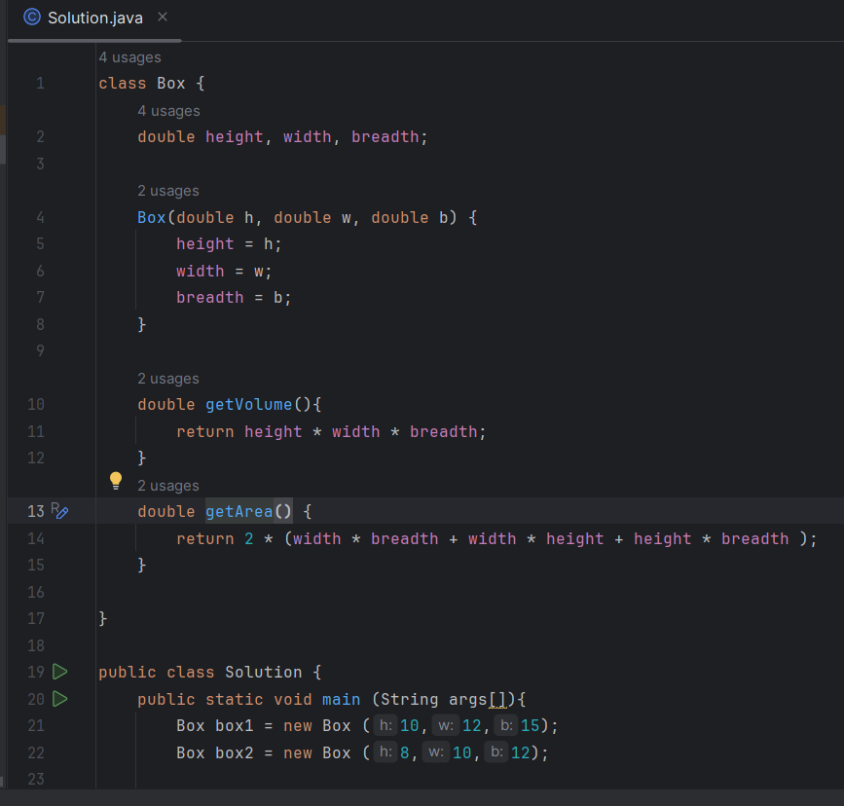

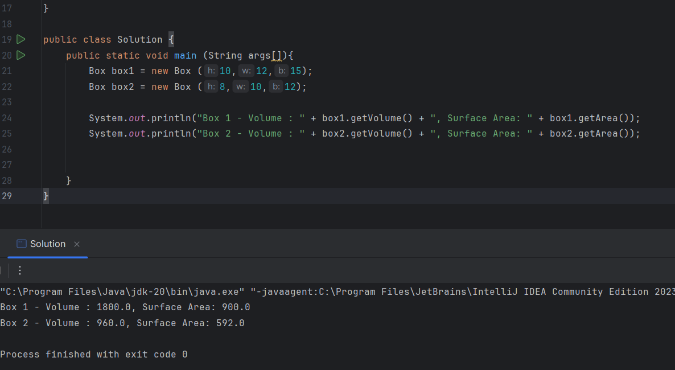

Q4. Complex Number Operations Create a class to represent complex numbers. Include the following constructors:

1. A default constructor that sets both real and imaginary parts to 0 2. A constructor that initializes the real part only

3. A constructor that initializes both real and imaginary parts Also, write member functions to:

● Add two complex numbers

● Multiply two complex numbers In the main() method:

● Create two complex numbers: 3 + 2i and 4 - 2i

● Display their sum and product

Ans :

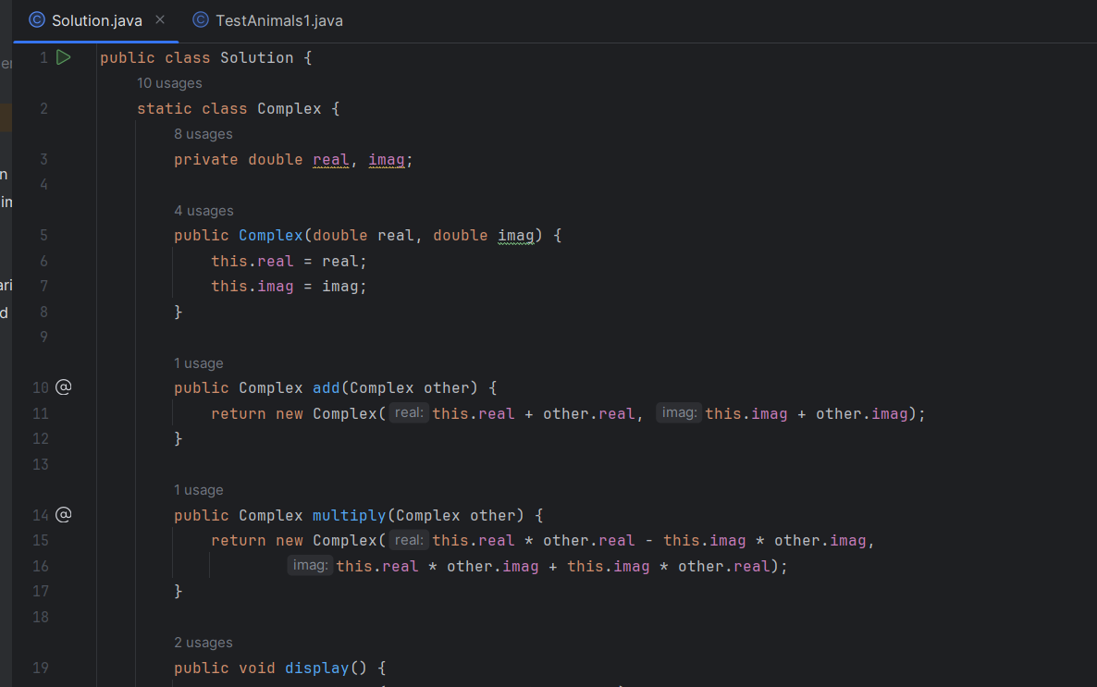

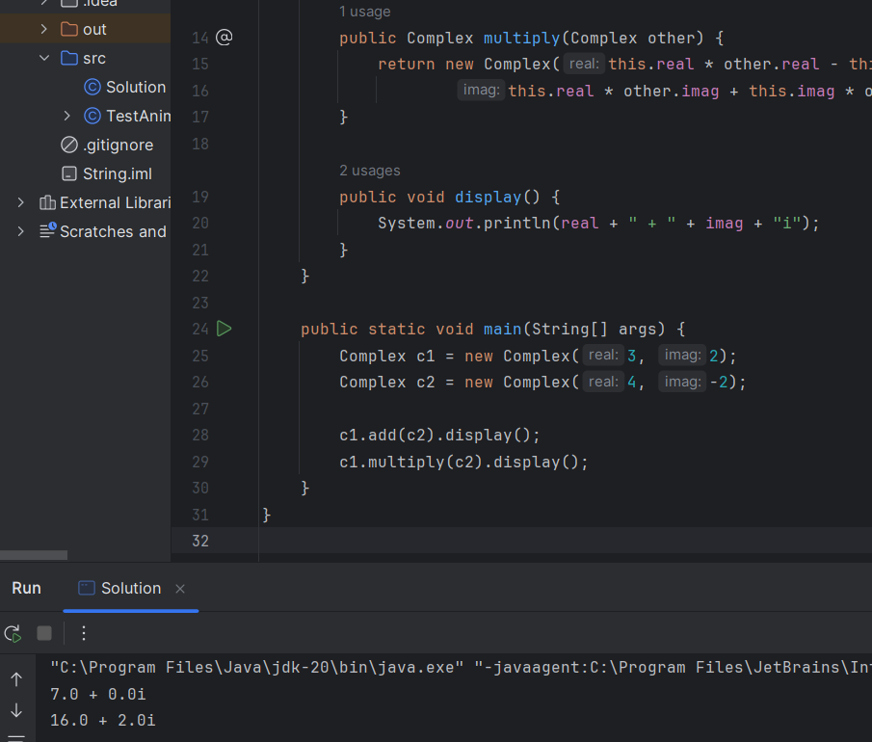

Q5. BMI Calculator Design a Java program to implement a BMI (Body Mass Index) calculator. The program should consist of a class named BMICalculator with the following specifications:

Class: BMICalculator

Fields

● height (double): To store the height of the person in meters

● weight (double): To store the weight of the person in kilograms.

Constructors

● A parameterized constructor to initialize the height and weight fields.

Methods

● Getter and Setter methods for both height and weight.

● double calculateBMI(): This method calculates and returns the BMI using the formula: BMI=weight(height×height)\text{BMI} = \frac{\text{weight}}{(\text{height} \times \text{height})}BMI=(height×height)weight

Main Program : Write a separate class containing the main() method to

1. Create an object of the BMICalculator class.

2. Prompt the user to enter their height and weight.

3. Use setter methods to assign these values to the object.

4. Call the calculateBMI() method to compute the BMI.

5. Print the calculated BMI to the cons

Ans :

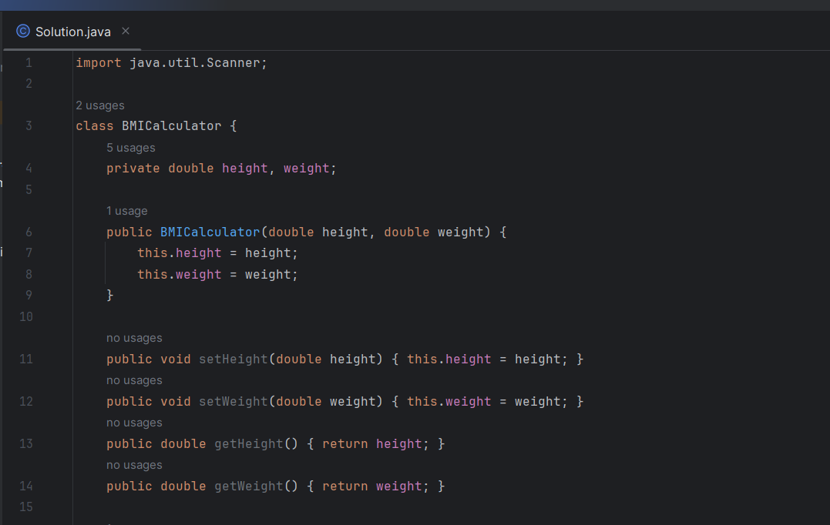

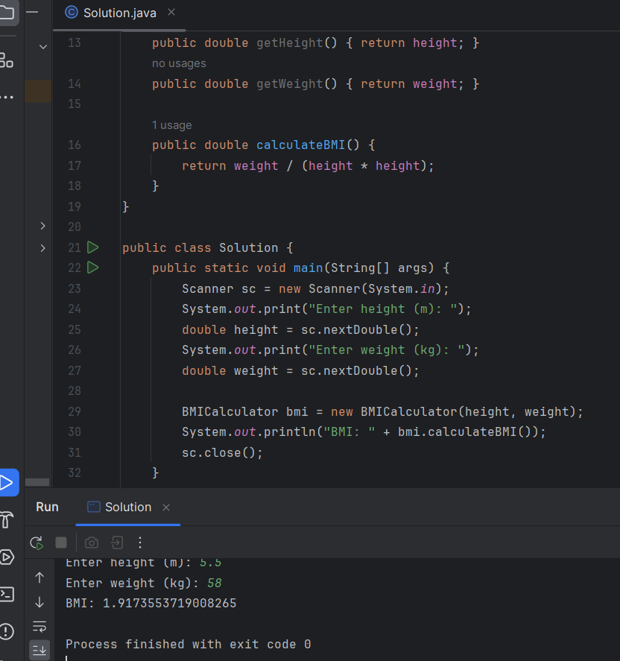

Q6. Electricity Bill Calculation – Java Program

Design a Java program to calculate the electricity bill for a customer based on the number of units consumed. Implement a class named ElectricityBill with the following specifications:

Class: ElectricityBill

Instance Variables

● customerName (String): Name of the customer

● unitsConsumed (double): Number of electricity units consumed

● billAmount (double): The calculated bill amount

Constructor

● A parameterized constructor to initialize the customerName and unitsConsumed fields. Method

● void calculateBillAmount(): This method calculates the electricity bill amount based on the following tariff rules:

○ First 100 units: Rs. 5 per unit

○ Next 200 units (i.e., 101 to 300): Rs. 7 per unit

○ Remaining units (above 300): Rs. 10 per unit

Main Program

In the main() method:

1. Create an object of the ElectricityBill class.

2. Set the customerName and unitsConsumed values (can be taken from user input or hardcoded).

3. Call the calculateBillAmount() method to compute the bill.

4. Display the customer's name, units consumed, and final bill amount.

Ans :

